**Assignment 1**

**Objective:**

Write a program to input an Alphabet and then determine whether given Alphabet is valid or invalid

**Code:**

#include <stdio.h>

#include <stdlib.h>

//Vishal B16101182 Assignment-1

//Objective: Write a program to input an Alphabet and then determine whether given Alphabet is valid or invalid

int main()

{

int i=0,n,isTrue=1;

printf("Enter Number of letters/elements of Alphabet : "); //These lines of code take number of characters in Alphabet

scanf("%d",&n);

printf("\n");

char *A[n];

printf("Enter Alphabet = \n{ \n");

for(i=0;i<n;i++){ //this loop fills the array with letters

A[i]=(char*)malloc(n);

scanf("%s",A[i]);

}

char First_Char ,Check_Char;

int ArrayLength = sizeof(A)/8; //Size of Array

for(i=0;i<ArrayLength;i++) //This is main loop which picks a letter

{

char *Letter= A[i]; //Letter contain letters of Alphabets

First_Char = Letter[0]; //First_Char contains first character of letter

for(int j=i+1;j<ArrayLength;j++) //This Loop checks whether same letter is present in Alphabet set or not

{

char *Letter1 = A[j];

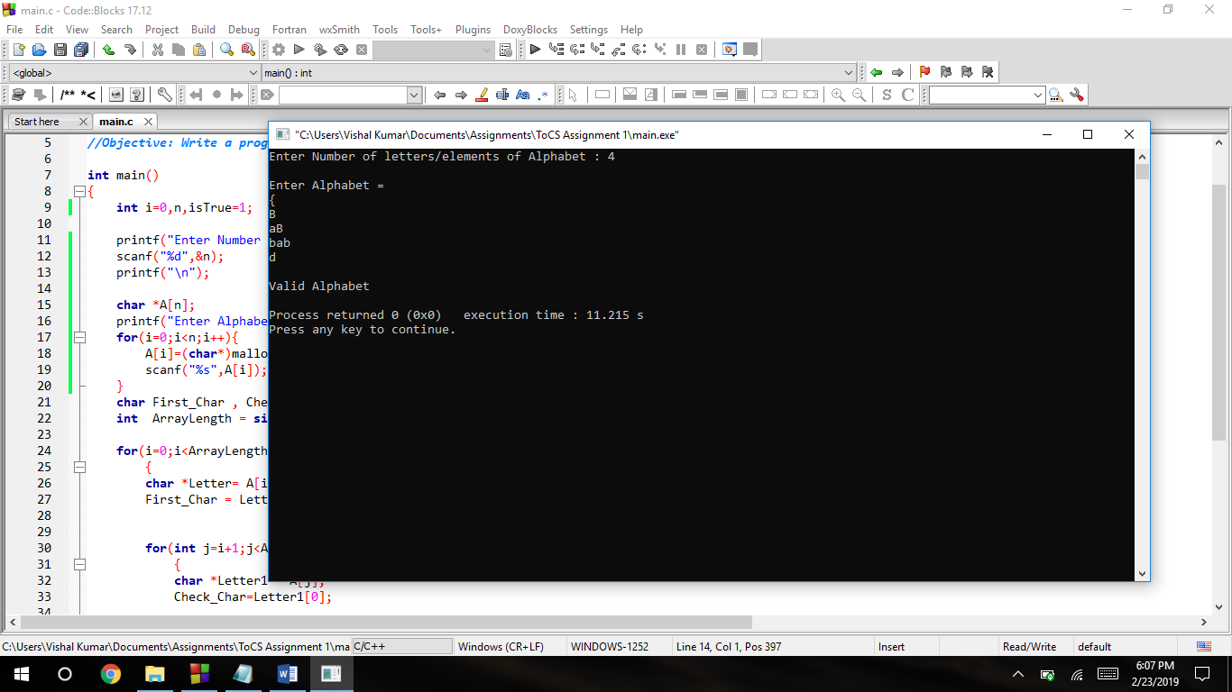Check_Char=Letter1[0];

if(First_Char==Check_Char)

{

isTrue=0;

break;

}

}

}

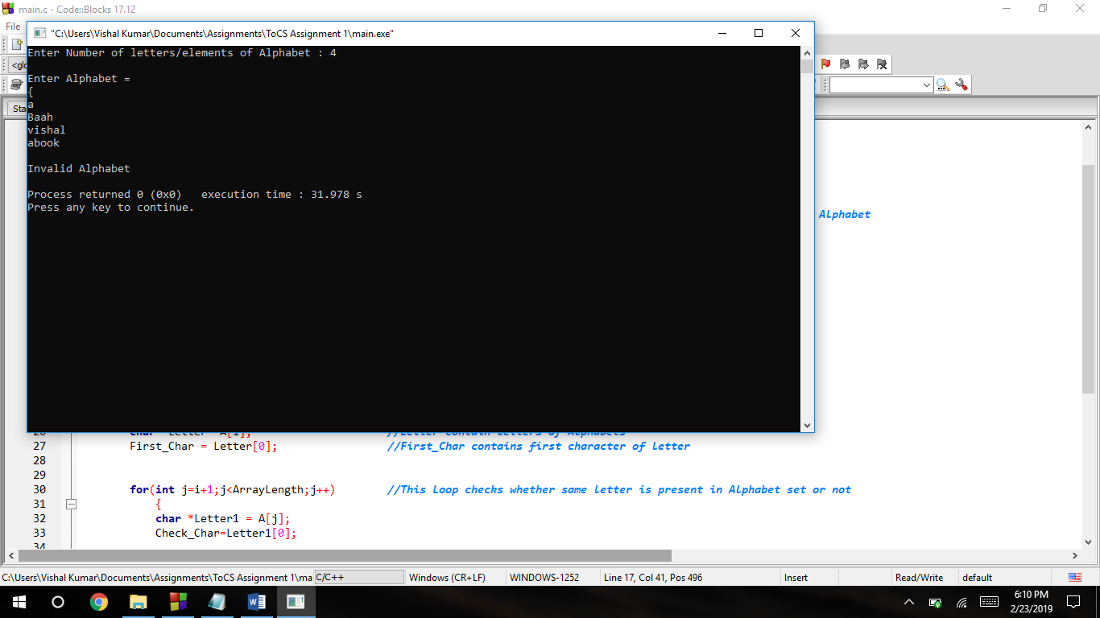 if(isTrue==1)

printf("\nValid Alphabet\n");

else

printf("\nInvalid Alphabet\n");

return 0;

}